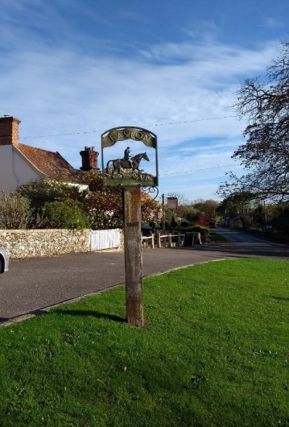.

**A SPECIAL ARCHEOLOGICAL DISPLAY**

A table display of the most significant finds along with a visual presentation by SCC Archeological Services. SCC will be manning this exhibition throughout the day. You will be able to understand the results of the dig prior to Hopkins Homes building the new estate next to the School.

**VISUAL PRESENTATION AT 2PM -**showing the dig and how the finds have been collected and recorded followed by question time.

**Your Village Your Say**

**Come and see**

The results of the Questionnaire and progress so far, and comment.

**There will be**

**An Exhibition** of the History of Easton including Audio and Visual of an ancestor of the ‘Hamilton ‘Seat’