PROPOSAL FORM

Community Infrastructure Levy Proposal Form

Submit a local infrastructure project for funding from the Community Infrastructure Levy

Suffolk Coastal and Waveney District Councils both have a Community Infrastructure Levy (CIL), which charges developers on most types of new buildings. The funds raised are spent on infrastructure provision to support development planned in the two Councils’ respective Local Plans. The Levy largely replaces the old system of Section 106 planning obligations. However, Section 106 will still be used for some site specific infrastructure and affordable housing.

This form provides an opportunity to propose a local infrastructure project to receive funding raised by the Community Infrastructure Levy. The types of projects that Community Infrastructure Levy funds can be spent on are listed in the Regulation 123 lists, which are adopted and published separately by both Councils and can be found at www.eastsuffolk.gov.uk/CIL. Community Infrastructure Levy funds cannot be used to reduce existing funding deficits unless it can be proven that these have been exacerbated by new development. Funding can be spent on projects outside of Suffolk Coastal and Waveney if these projects bring benefits to development in either of these two Districts. Please note: Community Infrastructure Levy funds are limited and not all project proposals will receive funding.

Completed forms should be sent by email or post to:

Proposals in Suffolk Coastal District: Proposals in Waveney District:
suffolkcoastallocalplan@eastsuffolk.gov.uk waveneylocalplan@eastsuffolk.gov.uk
Suﬀolk Coastal District Council Waveney District Council
Planning Policy and Delivery Team Planning Policy and Delivery Team
East Suffolk House Riverside
Riduna Park 4 Canning Road
Station Road Lowestoft
Melton Suffolk
Suffolk NR33 0EQ
IP12 3RT

01394 444588 01502 523065

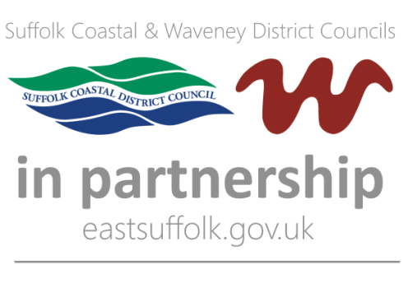

Project name

Location

Project contact details

Title
Name
Address
Email
Telephone

Purpose and scope of project

Please explain how this project is supporting development and links to District Council plans or strategies. Please remember that in order for a project to be approved by the Council’s Cabinet to receive CIL funding, it should:
- Be a type of infrastructure included on the Council’s Regulation 123 List
- Be a project on which work can usually start or be committed to within the current financial year.

Aims and objectives

What level of importance does CIL funding have for this project?

Project timescales

Duration of project
Start date
Completion date
Reason for deadline

Cost of project

Total cost of project (including funding secured to date)
CIL funding requested
Stakeholders

Current funding

Current funders / contributors
Provisional funding
Agreed funding
Committed funding
Other funders approached

Additional information

The information you have supplied is being collected in accordance with the Community Infrastructure Levy Regulations 2010. By returning this form you consent to Waveney District Council holding and using your information in this way.

By submitting this form you are accepting that your response will be available for public inspection in accordance with the Regulations stated above. However, personal/email addresses, and telephone numbers will not be published.

Data will be processed and held in accordance with the Data Protection Act 1998 (and any updates). Data will be retained for a period of one year.

Further information about data protection can be found on the East Suffolk website http://www.eastsuffolk.gov.uk/yourcouncil/access-to-information/data-protection-act/

