Your Village
Your Say
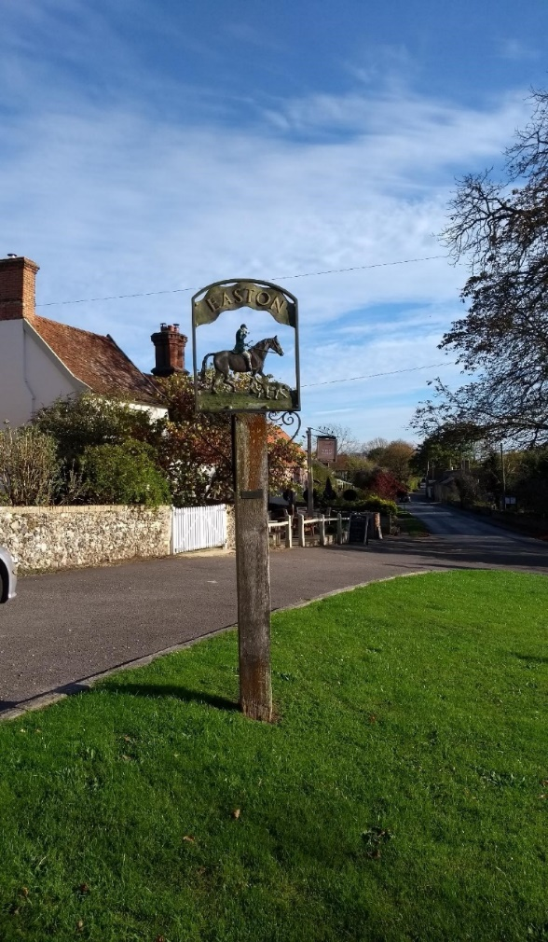

You are Invited to come, and enjoy
Hot Chocolate, Coffee, Tea & Homemade Cake
There will be display boards and a chance to give and record your comments.

Issues of importance to the Village such as Housing, Roads, Countryside, Historic Character, Ecology and Economics, are part of the plan.

A Neighbourhood Plan sets new housing numbers and locations within the Parish. The Community has a chance to give their views to help form the Policies that will make the Neighbourhood Plan; it then becomes a statute legal planning policy alongside the SCDC & National Policies.

