EASTON PARISH COUNCIL
MINUTES OF ANNUAL VILLAGE MEETING

Held on Friday 27th May 2022 at 7.30pm

Easton & Letheringham Village Hall

Reports from District, County Councillors and Question time for members of the public –Duration time maximum 10 minutes - 2 minutes per person re Agenda items.

1 members of public in attendance.

Meeting opened 7.30pm

 | PRESENT & APOLOGIES  Present  Cllr S Piggott – Chair  Cllr D Balcombe  Cllr M Birt  Cllr G Edwards  Alison Bramall – Parish Clerk/RFO | Apologies:  Cllr B Gibbon  Cllr F Siddall - Vice-Chair  Cllr I Palfreyman  County Cllr E Bryce  District Cllr L Freeman
- 2 | DECLARATIONS OF INTERESTS  - None
CONSIDERATION OF ANY DISPENSATION REQUESTS –
- None

PARISH COUNCIL REPORT – CHAIRS REPORT
Sue Piggott, Easton Parish Council Chair
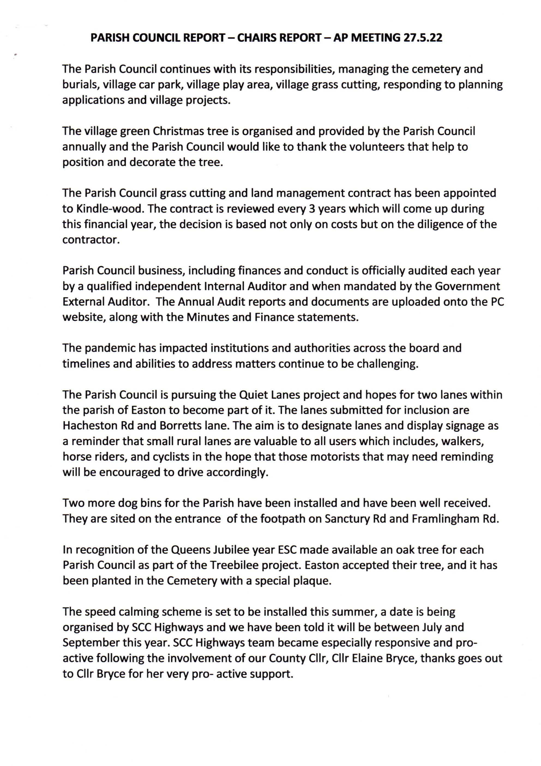
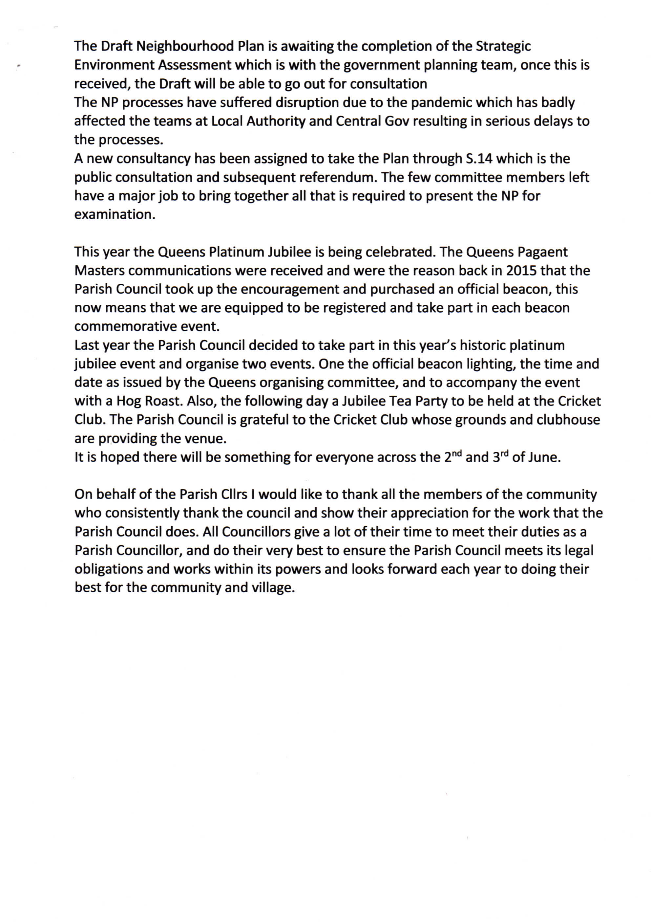

EASTON & LETHERINGHAM VILLAGE HALL COMMITTEE REPORT - Jenny McEvoy – Chair - Easton and Letheringham Village Hall Committee
During the majority of 2021/22 the VHMC continued to be impacted both in hirer income and maintenance activities with a second year of Covid restrictions. A small number of our regular Hirer groups continued to operate with lower numbers, masks and social distancing and continuous ventilation to reduce transmission, which contributed to higher energy costs. My thanks to Jean & Christine for your support in continuing to assist in compliance as the ever-updating guidance and Winter Plan B and roadmap to reopening in line with advice from the government and our advisors. We did not find ourselves having to close the hall during this time due to any outbreaks.
The Sunday Café made a welcome return after two years in February, along with the long-awaited Quiz Night in March, which was wonderful for the community to come together once again after such a long period of time. We also welcomed back the dance class and Monday Mardles. Hires continued to be varied, at times seeing late cancellations due to omicron over winter and spring, but we hope a return to more normal patterns of activity after such a long period of uncertainty.
Overall hirer income was down by a third for the year on pre-pandemic levels. With running costs disproportionately high due to the covid interruptions and mitigating measures necessary during the year. An old building demands attention and now with more certainty we shall be rescheduling paused maintenance, albeit against a backdrop of increasing labour and material costs to ensure the hall is kept in good order.
My special thanks to the committee, especially Christine, who volunteered to clean the hall for several months as due to the uncertainties of usage and finding a cleaner is not an easy in this locality. This resulted in much lower expenditure than would have been. A big Thankyou also to our hall neighbour, Peter who continues to keep the hall garden and hedge in good order, we are always very grateful for your voluntary support and hard work over many years in this regard. We welcomed our new Treasurer Guy onboard, who was co-opted onto the committee in November.
As always, a big Thank you for the ongoing work and support of the Trustees as we continued to navigate such unusual times. We hope that life can once again return to normal, and more leisure events can be held to bring the community together once again.

5 | EASTON CHURCH REPORT - Jane Woodbury Eggins – Church Warden  It has been good to get back to regular services even though our numbers are still below those we had before the pandemic. We are planning a Songs of Praise for the Jubilee Sunday.  There were no baptisms in 2021 but we had two lovely weddings even though the numbers at the time were restricted.  Zoom services have continued but are now on a monthly basis. They are useful for some who find it difficult to get to church. Those without tech can have service sheets for use at home.  As you know the East Suffolk Council is only cutting the grass in the church- yard once a year. We are happy to do our bit for "feeding the bees" but cut the area next to the path to keep it tidy and more welcoming. Most people have remarked that they like the long grasses and we hope more wild flowers will appear over time.  We again paid our full Parish Share for Easton in 2021 of £9,000. This was done from reserves as income is still much down. The reserves will not last for many years and the future is worrying even with a return to services and fundraising. People often have the idea that the church is rich, but this Diocese has no historical funds (it is only just over 100 years old). Every parish or benefice (ours is 7 churches) has to pay for its own priest, his or her stipend, training, pension and housing, as well as central administration. It's a big ask in small parishes. The training budget also includes lay elders and churchwardens and safeguarding training for all involved.  Easton Primary School has been able to have its usual Christmas and Easter services and it was really great to see them all back and singing so well. We treasure our links with the school.  We are lucky to have a great parish magazine produced by Clare Owen. The general interest items and (usually) forthcoming local events are really useful. Our magazine has been in electronic form since the first lockdown and some people actually prefer it that way. A few paper copies are made for those who need it. The benefice as a whole is going to have one magazine only in the near future.

EASTON BOWLS CLUB REPORT - Mike Cattermole – Chairman
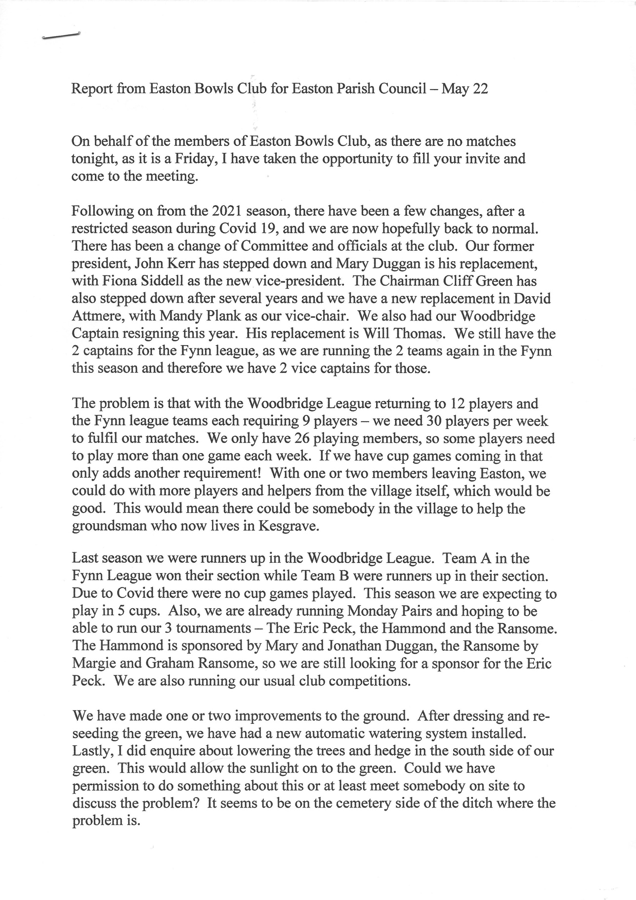
CLOSE
The Chair thanked everybody for attending the meeting.

The Chair closed the meeting at 20.30
……………………………………………………. ……………………………….
Chair Date

